# Wei™ Dashboard:

Wei Dashboard is a web application that provides the ability to view messages that are processed through Wei Translator Service on a real time basis. Wei dashboard also provides a mechanism for reconciling the messages that have been processed through Wei Translator Service for a given date or for date ranges.

The Dashboard by default will list all the messages with their current status that are either processed or currently being processed by Wei Translator Service for the current date. The grid that displays the messages will be refreshed based on the value set in the configuration file. The following message information will be displayed on the screen:

**ID** – Request ID, which is a unique identifier associated with a request.

**Message ID** – unique identifier associated with a message.

**Interface Name** – Name of the interface. Ex File Interface or MQ Interface.

**Current Status** – Current status of the message. Possible values would be

* **UnProcessed**  - The message from payment system was picked up by Wei Translator Service.
* **Translated** – The message with CTC was translated to English
* **SentForOFACCheck** – The message with CTC was translated to English and sent to OFAC Filtering software for OFAC check.
* **OFACResponseRecieved** – The message was OFAC checked and a response was received. The response could be ‘OK’ or ‘Confirmed’ (OFAC hit was confirmed).
* **Processed** – The message was OFAC Checked and found to be clean to be picked up by the payment system

**OFAC Violation** – Specifies if there was an OFAC Violation. The possible values are:

* **Confirmed** - OFAC violation has been confirmed in OFAC Filtering Software
* **OK** – OFAC violation has been waived in OFAC Filtering Software
* **UnProcessed** – OFAC Violation in

**Create Date –** Date and time when the request was created.

**Modified Date –** Date and Time when the request was modified.

The below screenshot displays messages with current statuses as of the current date.

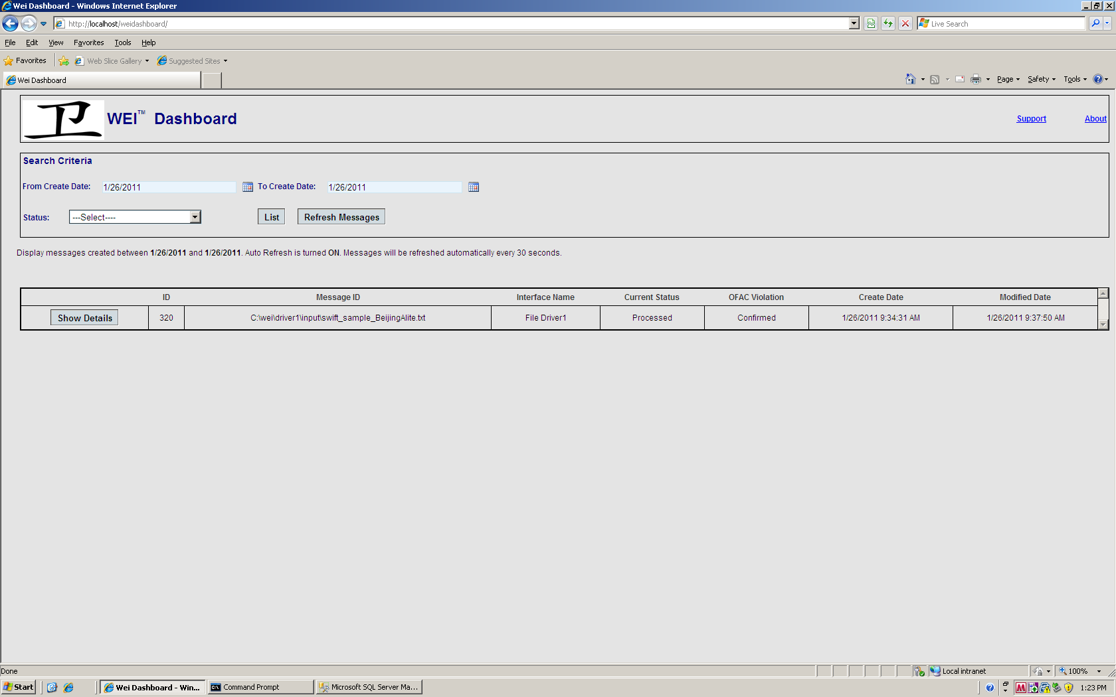

**Wei Dashboard to display messages for current date. Grid Auto Refresh turned on by default**

The Dashboard also provides the ability to search messages based on date ranges and message statuses. The grid refresh will be automatically turned off, when the user provides search criteria and clicks on the “List” button. A message will be displayed showing the selected criteria and that the grid refresh is turned off. In order to turn on the grid refresh, the user will have to click on “Refresh Messages” button.

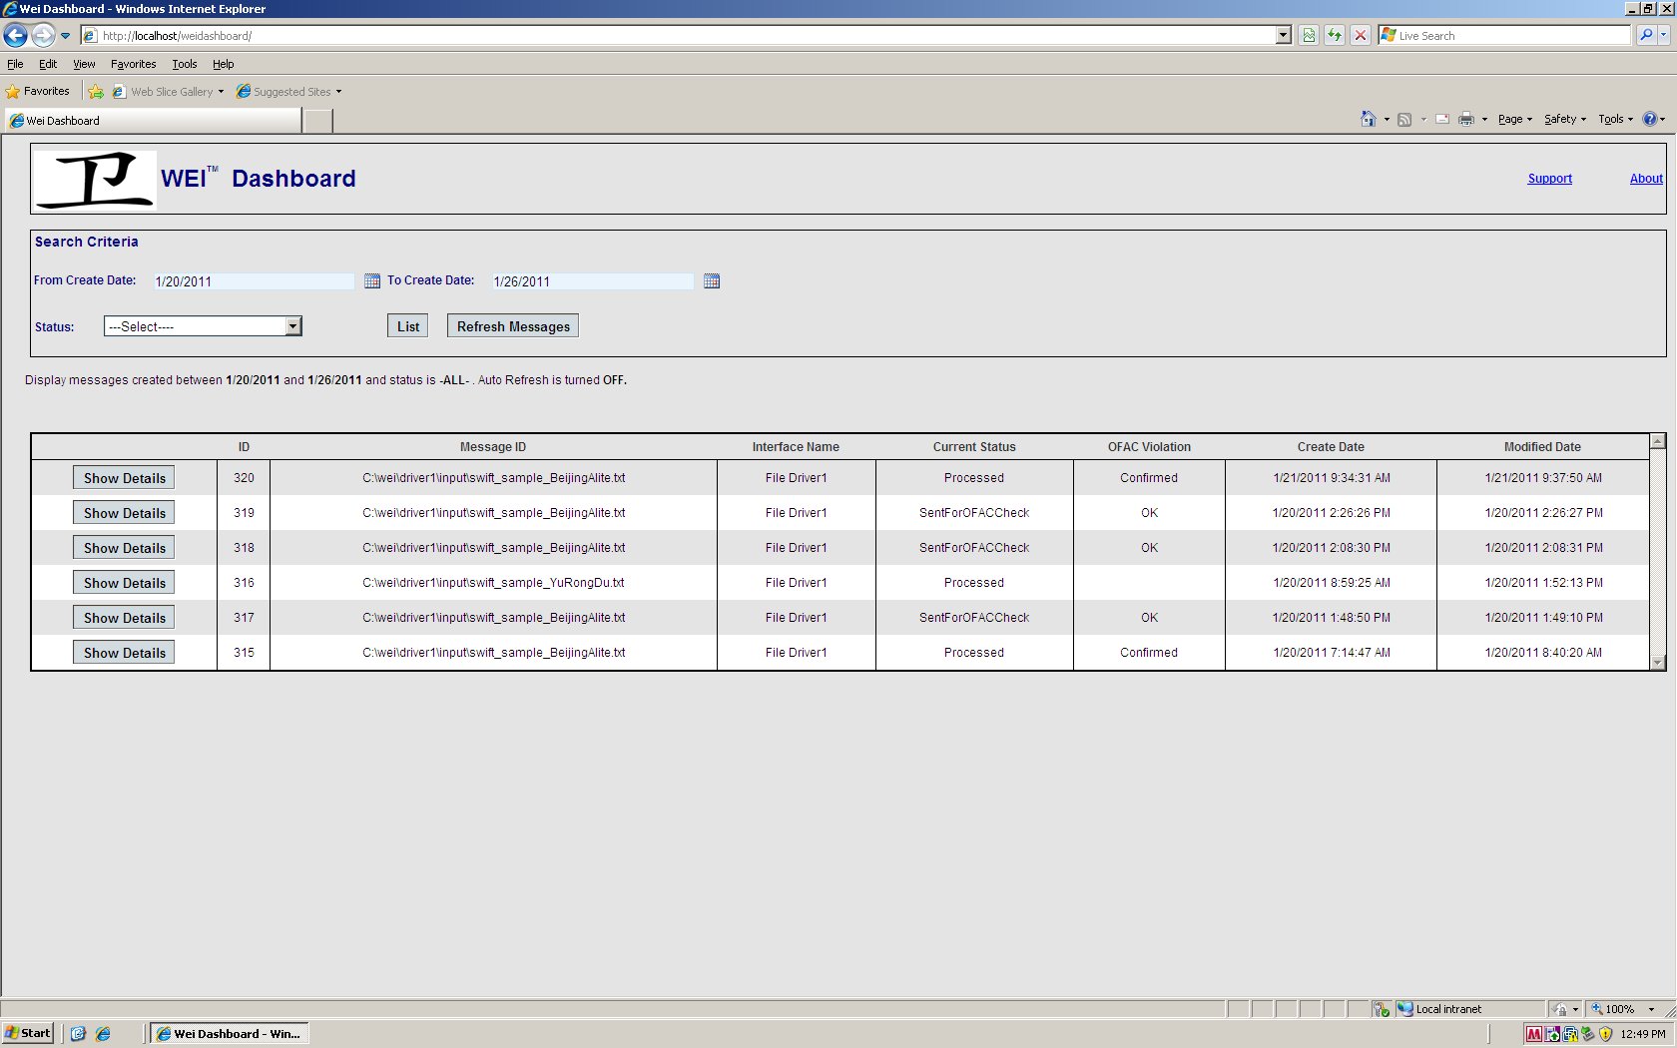

**Wei Dashboard displays messages that have been specified with Search Criteria. Grid Refresh will be turned off.**

Clicking on the “Show Details” button will display the message details popup screen.

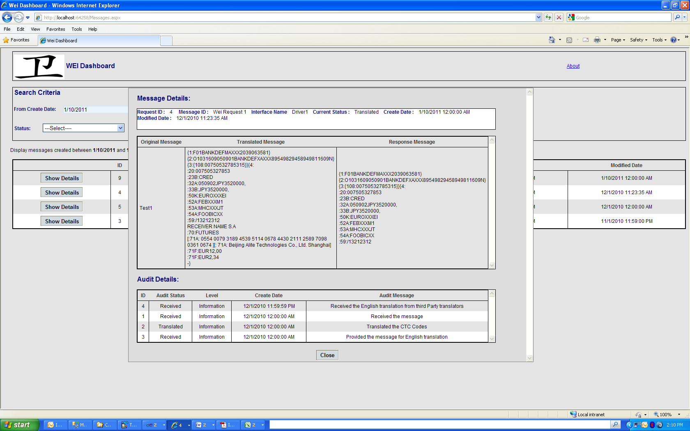

The top grid displays the Original Message, Translated Message and “Response Message”. The “Original Message” represents the message that was received from the external system(s). The “Translated Message” represents the message that has been translated to English, corresponding to CTC. The English translation will be displayed next to the Chinese Telegraphic codes. The “Response Message” will display the message that has been altered to include the OFAC Matches info into the original message.

The Audit Details grid will display the Audit information for a message for a particular request. The following columns will be displayed:

**ID –** Unique Identifier associated with Audit message

**Audit Status –** Status of the Audit message

**Level –** Severity of the Audit Message. Possible Values are:

* Information
* Debug
* Error

**Create Date –** Date when the Audit Message was created.

**Modified Date -** Date when the Audit Message was modified.

**About:** The About screen will display the following information:

